**REPORT**

Zajęcia: Analog and digital electronic circuits

Teacher: prof. dr hab. Vasyl Martsenyuk

**Lab 14**

30.04.2025

**Topic:** "Implementation of Real-Time Signal Processing Algorithms"

**Variant: 13**

Rafał Żmuda

Informatyka II stopień,

stacjonarne,

1 semestr,

Gr.2b

1. **Problem statement:**
2. Simulate and process ECG signal in real-time-like fashion
3. Implement and simulate a Kalman-Bucy filter for a continuous stochastic system.
4. **Input data:**

Variant 13:

- ECG Sampling Rate: 360 Hz

- ECG Duration: 12 seconds

- Block Size: 180 samples

- Kalman-Bucy Parameters: x = −x + w, y = x + v, Q = 2.0, R = 0.5

1. **Commands used (or GUI):**
2. **Simulating and processing ECG signal**

Signal generation and bandpass filter implementation

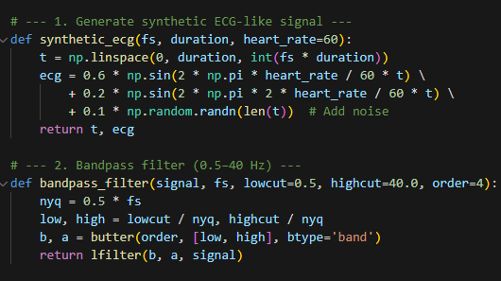

Function to implement real-time processing of the generated signal

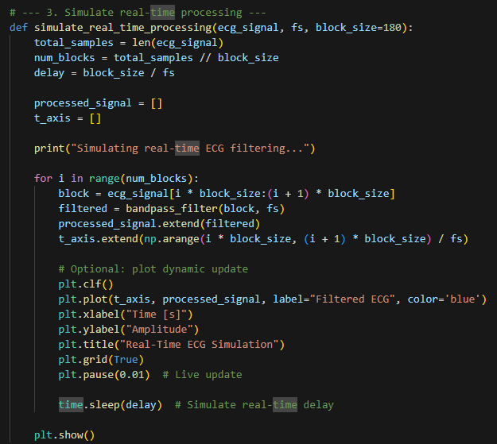

**Outcomes:**

Output of the simulate_real_time_processing() function after 24 iterations

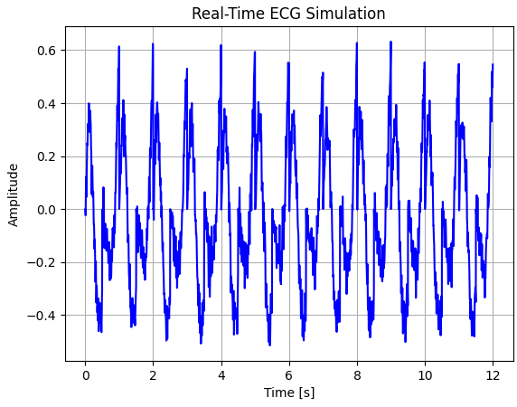

1. **Implement and simulate a Kalman-Bucy filter**

Implementation of Kalman-Bucy filter

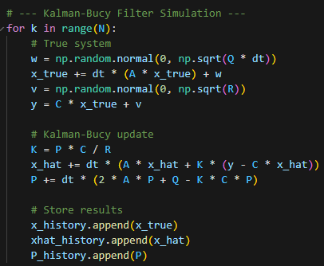

**Output:**

Output of the generated true state with the estimated state. We can see close correlation between the true state and estimation even in the presence of high noise

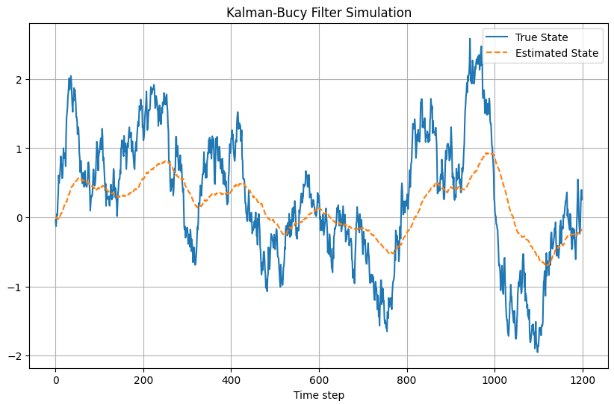

Link to remote repository: https://github.com/RafalZmu/School/tree/main/Lab%2014

**5. Conclusions:**

In this lab, We implemented real-time ECG signal processing and Kalman-Bucy filtering. The ECG simulation demonstrated how block-based filtering effectively removes noise in a real-time-like manner. The Kalman-Bucy filter accurately estimated the system state despite noise, showcasing its robustness.